A PROJECT REPORT
On
Voting Application Collage Website
Submitted By
Name of Students Enrollment No
Abhishek Pandurang Joshi 2110950057

Aniket Bharat Ghotale
Somesh Mahadev Bharbade
Sujit Sudhakar Sukane
2110950151

2110950103

2110950159





Vishweshwarayya Abhiyantriki Padvika Mahavidyalaya Almala. Tq. Ausa Dist. Latur
In Partial Fulfillment of

Diploma in Computer Engineering
Under the Guidance of Prof. Sugre D.D.
For the Academic Year

2023 – 2024


Shri Vishweshwar Shikshan Prasarak Mandal’s Vishweshwarayya Abhiyantriki Padvika Mahavidyalaya, Almala

Certificate
This is to certify that Mr. Abhishek Pandurang Joshi, Mr. Aniket Bharat Ghotale, Mr. Somesh Mahadev Bharabade, Mr. Sujit Sudhakar Sukane students of our institute from Third Year Computer Engineering (CO6I) have successfully completed the Project on “VAPM Collage Website” of course “Capstone Project Execution and Report Writing (22060)” as part of curriculum by the Maharashtra State Board of Technical Education, Mumbai.
For partial fulfilment of “Diploma in Computer Engineering” during the academic year 2022-23.

Guide HOD
Prof. Sugre D.D. Prof. Kazi A.S.M

Project Coordinator Principal
Prof. Sugre D. D Prof. P. S. Dharashive

DECLARATION

We hereby declare that the project entitled “Voting Application Collage Website” submitted for 6th Semester Project work as per MSBTE Curriculum of Computer Engineering Course and the project has not formed the basis for the award of any degree, fellowship or any other similar titles.

Place: Almala | 1) Mr. Abhishek Pandurang Joshi | 2110950057
Date: | 2) Mr. Aniket Bharat Ghotale | 2110950151
 | 3) Mr. Somesh Mahadev Bharbade  4) Mr. Sujit Sudhakar Sukane | 2110950103  2110950159

ACKNOWLEDGEMENT

We would regard this project as the culmination of efforts put by various persons during this academic year. We express the whole hearted thanks to our guide Prof. Sugre D.D. for such priceless and affectionate guidance throughout the project, without which this report would only be a dream. We also express our sincere thanks to Head of Department Computer Engineering Prof. Kazi A.S.M for providing all necessary prerequisites. We express our deepest regards towards the staff members and friends for their constant support. We express whole hearted thanks to our principal of VAPM, Almala College Prof. Dharashive P.S for providing all necessary infrastructures, labs, etc.

CONTENTS

Sr. No. | Name of Chapter | Page No.
1 | INTRODUCTION  - Importance of Voting Application.  - Objective  - Significance of research  - Organization of the thesis | 4-5
2 | Literature Survey  - Need of our system  - Existing system  - Problem statement
3 | Scope of Project
4 | Methodology  4.1 Introduction to Methodology  4.2 Requirements  4.3 Technologies  4.4 Implementation  4.5 Limitations
5 | Details of designs, working and processes  5.1 Data Flow Diagram (DFD)  5.2 Working of the System  5.3 Processes Implemented  5.4 Future Improvements
6 | Results and applications  6.1 Results  6.2 Applications
7 | Conclusion and Future Scope  7.1 Conclusion  7.2 Future Scope
8 | Appendix(if any)
9 | References and Bibilography

CHAPTER 1

PROJECT INTRODUCTION:

The Importance of Voting Application Collage Website:

Convenience is another key advantage of the Voting Application Collage Website. With its user-friendly interface, students can easily navigate the platform and cast their votes at their own convenience. This eliminates the need for long queues and cumbersome administrative procedures, streamlining the entire voting process. Additionally, the platform automates various tasks such as voter registration and ballot counting, reducing the workload on election organizers and ensuring efficient execution of elections.

Engagement lies at the heart of the Voting Application Collage Website, as it seeks to empower students to actively participate in the democratic process. Through features such as candidate profiles, election forums, and educational resources, the platform encourages informed decision-making and meaningful participation. By fostering a sense of civic responsibility and political awareness, the website cultivates a vibrant campus community where students are actively involved in shaping their institution's future.

In essence, the Voting Application Collage Website represents a significant advancement in democratizing student elections. Its accessibility, convenience, transparency, engagement, and data-driven approach underscore its importance in promoting democratic values within educational institutions. By embracing technology to facilitate fair and inclusive elections, the platform paves the way for a more vibrant and participatory campus community.

For Institutions:
- Online Presence and Visibility:
A website acts as the digital face of the institute, providing an online presence that is accessible 24/7 to prospective students, parents, and stakeholders.
- Marketing and Branding:
The website serves as a powerful marketing tool, helping the institute showcase its achievements, facilities, faculty, and unique features to attract potential students.
- Information Hub:
Centralized platform for disseminating information about elections, students, academics, candidates, and other important information.
- Accessibility Hub:
Have provided filter option for students and candidate to ensure smooth operation when the data is too large. Have provided admin dashboard for easy access.

- For Students:
- Information Access:
Students can easily access important information such candidates, elections and vote the candidates.
- Security:
The website makes sure the student can only vote one for a particular election and each student has their separate login.

Objective

Main Objective:
` The main objective of the Voting Application Collage Website is to modernize and enhance the electoral process within educational institutions by leveraging technology. It aims to increase accessibility and participation among student voters by providing a user-friendly platform for casting votes from anywhere with an internet connection. The website streamlines the voting process, automating administrative tasks and ensuring efficiency. Transparency and integrity are prioritized through real-time updates on voter turnout and results, coupled with robust security measures to prevent tampering or fraud. Moreover, the platform seeks to foster engagement and civic responsibility among students by offering informative resources and encouraging informed decision-making. By generating valuable data insights, the website also contributes to ongoing research on student politics and democratic participation, ultimately promoting a more vibrant and participatory campus community.

Sub-Objectives:
- Digital Transformation:
  - Transition traditional voting processes into an efficient, digital format, reducing manual paperwork and enhancing accessibility.
- Streamlined Admission Process:
  - Simplify the admission process for prospective students by providing a user-friendly online platform to submit applications, upload documents, and track application status.
- Enhance Accessibility:
  - Enable students to cast their votes from anywhere with an internet connection, eliminating geographical barriers.
  - Promote inclusivity by ensuring all eligible voters can participate in the electoral process.
- Improve Convenience:
  - Streamline the voting process, reducing the need for long queues and cumbersome paperwork.
  - Automate administrative tasks such as voter registration and ballot counting to save time and effort.
- Ensure Transparency:
  - Implement robust security measures to safeguard against tampering or fraudulent activities, ensuring the integrity of the elections.
- Foster Engagement:
  - Encourage active participation among students by offering features such as candidate profiles and election forums.
- Security and Privacy:
  - Implement robust security measures to safeguard sensitive information, including student records, personal data, voting data while ensuring compliance with data protection regulations.

Significance of Research
Research plays a pivotal role in the development of the Voting Application College website, serving as the compass guiding every phase of the project. By delving into user needs and expectations, research provides invaluable insights into the diverse requirements of students, faculty, staff, and other stakeholders. This understanding enables the project team to tailor the website's design, features, and content to best serve its intended audience. Furthermore, market analysis helps identify emerging trends and competitive benchmarks, ensuring that the website remains contemporary and stands out amidst similar institutions. Accessibility research ensures that the website accommodates users of all abilities, fostering inclusivity and compliance with regulatory standards. Moreover, thorough investigation into technology stacks and UX design principles ensures the selection of robust, user-friendly solutions that enhance the website's performance and usability. Ultimately, research serves as the bedrock upon which the VAPM College website is built, ensuring its relevance, effectiveness, and resonance within the educational landscape.

Organization of The Thesis
The thesis is organized as follows:

Chapter 1
Motivation, The Importance of Voting Application, Objective of the research.

Chapter 2
Reviews the previous work done in the areas of election or technologies field that are improved using real life aspect and cutting-edge technologies.

Chapter 3
Define and analyze scope of project

Chapter 4
Define Data flow diagram, E-R diagram and technologies.

Chapter 5

Detailed overview of designs, works and processes. Explaining processes, designs of all modules within the project.

Chapter 6
Defining the results of overall project and providing an overview of results. Defining the applications of project that you have created until now.
Chapter 7
Explain your conclusion of overall project and define the future scope of your project. Level).

CHAPTER 2

LITERATURE SURVEY

Need of Our System:

The need for a voting application system tailored for colleges arises from several factors that influence the dynamics of student elections and democratic participation within educational institutions. Firstly, traditional methods of conducting elections, such as paper-based ballots or in-person voting, often pose logistical challenges and can lead to low voter turnout. This is especially true in larger colleges where students may have conflicting schedules or face difficulties accessing polling stations. A voting application system addresses this need by offering a convenient and accessible platform for students to cast their votes remotely, thereby increasing participation rates and ensuring a more representative electoral process.

Moreover, the digitalization of voting processes aligns with the broader trend of integrating technology into various aspects of campus life. As today's college students are highly tech-savvy and accustomed to conducting tasks online, a voting application system meets their expectations for streamlined and efficient processes. By providing a user-friendly interface and automating administrative tasks such as voter registration and ballot counting, the system enhances the overall voting experience and reduces the burden on election organizers.

Transparency and accountability are also significant drivers behind the need for a voting application system in colleges. Traditional paper-based voting systems may lack the mechanisms to ensure the integrity of elections and prevent instances of fraud or tampering. In contrast, a digital voting platform offers built-in security features such as encryption and audit trails, which enhance the transparency of the electoral process and safeguard against potential malpractices. Real-time updates on voter turnout and election results further reinforce trust in the fairness and legitimacy of the elections among students and other stakeholders.

Furthermore, a voting application system facilitates data-driven decision-making and provides valuable insights into student preferences and behaviors. By analyzing voter demographics, turnout rates, and candidate performance, college administrators can gain a deeper understanding of student dynamics and tailor their policies and initiatives accordingly. This data-driven approach not only improves the efficiency of electoral processes but also contributes to the overall governance and management of the college.

In summary, the need for a voting application system for colleges stems from the desire to modernize electoral processes, increase student participation, enhance transparency and accountability, and leverage data for informed decision-making. By embracing technology to facilitate fair, accessible, and efficient elections, colleges can foster a more vibrant and engaged campus community while upholding democratic principles and values.

Existing System:
- Low Voter Turnout:
  - Traditional paper-based voting methods often result in low voter turnout due to logistical challenges and inconvenience for students.
  - Students may face difficulties accessing polling stations or may not prioritize voting amidst their academic commitments.
- Manual Administrative Burden:
  - Organizing elections using paper ballots requires significant manual effort in tasks such as distributing ballots, managing voter lists, and counting votes.
  - This manual administrative burden can be time-consuming and prone to errors, leading to delays in election results and potential discrepancies.
- Limited Accessibility:
  - Physical polling stations may not be easily accessible to all students, especially those with mobility issues or students studying remotely.
  - Lack of alternative voting methods restricts participation among students who are unable to physically attend polling stations.
- Security Concerns:
  - Paper-based voting systems are susceptible to security risks such as tampering, ballot stuffing, or unauthorized access to ballot boxes.
  - Ensuring the integrity and confidentiality of the voting process becomes challenging without robust security measures in place.
- Lack of Transparency:
  - Manual vote counting processes may lack transparency, making it difficult for students and stakeholders to verify the accuracy of election results.
  - Limited visibility into the electoral process may lead to concerns regarding fairness and legitimacy among the student body.
- Complexity in Voter Verification:
  - Verifying voter eligibility and preventing multiple voting instances can be challenging in paper-based systems without efficient mechanisms in place.
  - Ensuring that only eligible students cast their votes while maintaining anonymity poses a logistical challenge for election organizers.
- Difficulty in Voter Engagement:
  - Traditional voting methods may fail to engage students effectively, particularly younger or first-time voters, due to lack of interactive features or educational resources.
  - Engaging students in the democratic process and encouraging informed voting becomes more challenging without accessible and engaging platforms.
- Limited Data Insights:
  - Paper-based voting systems offer limited opportunities for collecting and analyzing data on voter demographics, preferences, and turnout patterns.
  - Lack of data insights hampers the ability of colleges to understand student dynamics and tailor their policies and initiatives effectively.
Addressing these drawbacks requires a shift towards modernized voting systems that leverage technology to overcome logistical barriers, enhance transparency and security, and promote greater student engagement and participation.

Proposed System:

- For Admin Side:

Header: The top section of the home page includes the college logo, basic navigation, and
Logout Button.

Side Bar: Contains navigation for the entire admin panel with interactive logs to make the navigation more accessible and readable. It also contains dropdown menus for easy access of the menu

Quick Links: Below the featured content, quick links or buttons provide convenient access to commonly accessed pages such as students info, academic info, candidate profiles, and contact information user navigation and interaction.

Filters For Better Accessibility:
To enhance accessibility within the application and improve user experience, several filters have been strategically integrated. These filters serve as crucial navigational tools, facilitating easier access to data and enhancing the overall usability of the platform. By implementing these filters, users can effortlessly refine and customize their data views, ensuring that pertinent information is readily accessible.

Scalability:
Design the voting application with scalability in mind to accommodate an increasing number of users and voting events, ensuring optimal performance and user experience during peak periods.

Interactive Charts:
Implement interactive charts that allow administrators to hover over data points to view specific details, such as the number of votes received by each candidate from male and female students. This enhances the usability of the results page and enables administrators to easily analyze voting trends.

- For Students:
User Profiles:
Implement individual user profiles for students, faculty, and administrators to personalize the voting experience and provide tailored access to relevant information and functionalities.

Voter Authentication: Enhance voter authentication mechanisms to ensure the integrity of the electoral process and prevent unauthorized access or fraudulent voting.

Navigation: Users can navigate to the different pages either through the main navigation menu This navigation structure ensures easy access.

2.3 Problem Statement:
In modern college environments, nurturing active civic engagement and democratic participation among students stands as a paramount objective. However, conventional methods employed for student elections often encounter numerous inefficiencies and constraints that impede student involvement and compromise the integrity of the electoral process. Thus, there emerges a critical need for the development and deployment of a tailored voting application specifically designed for college settings. This application must confront challenges such as low voter turnout, transparency deficits, accessibility hurdles, and complex administrative procedures while also enriching user experience and advancing inclusive democratic practices within college campuses.

- Technologies:
- Frontend: HTML & CSS for a responsive and interactive user interface.
- Backend: JavaScript for server-side logic and API development.
- Database: MySql for efficient data storage and retrieval.
- Authentication: Implement secure authentication mechanisms for user access control.
- Deployment: Use modern deployment practices, possibly containerization with Docker.

- Expected Outcomes:
The development of the VAPM college website aims to deliver a user-friendly, comprehensive online platform that caters to the diverse needs of students, faculty, staff, and other stakeholders. The expected output includes a fully functional website with intuitive navigation, responsive design, and visually appealing interface. Users can expect to access a wide range of features and services.

- Significance:
The development of the VAPM college website holds significant importance in modernizing communication, accessibility, and administrative processes within the institution. By providing a centralized platform for information dissemination, the website improves communication channels among students, faculty, staff, and other stakeholders. It enhances accessibility to academic resources and administrative services, streamlining processes and promoting inclusivity. Moreover, the website enriches the learning experience through interactive tools and virtual classrooms, while also fostering alumni engagement and networking opportunities. Overall, the website's development not only enhances the college's reputation and competitiveness but also enables data-driven decision-making for continuous improvement.

- Target Users:
Instructors, administrators, and students of VAPM colleges & Student’s who are interested to take admission in VAPM Polytechnic.

CHAPTER 3

Scope of the Project

3.1 Project Scope:

Maintaining effective communication with stakeholders throughout the development process is essential for ensuring alignment with expectations and addressing any concerns or changes promptly. This involves establishing clear channels of communication, such as regular progress meetings, email updates, and feedback sessions. Stakeholders may include college administration, faculty members, student representatives, IT personnel, and any other parties involved in the project. Regular updates on project milestones, budget status, and potential risks should be provided to stakeholders to keep them informed and engaged. Additionally, maintaining an open line of communication allows stakeholders to express their feedback, suggestions, and concerns, enabling the project team to address them promptly and make necessary adjustments. By fostering transparent and collaborative communication, the project can proceed smoothly, with all stakeholders working together towards the successful development and implementation of the VAPM College website..
.

1. Home Page:
- Objective:
- The primary objective of the Home Page is to serve as the entry point to the VAPM College website, providing visitors with a welcoming and informative overview of the college, its offerings, and key highlights. It aims to engage users, direct them to relevant sections of the website, and showcase the unique features and benefits of VAPM College.
- Key Features :
- A brief overview highlighting the college's mission, vision, values, and historical background.
Engaging content to capture visitors' interest and encourage exploration of the website.
Latest news, events, and announcements displayed prominently.
Links to detailed news articles or event pages for further information.

2. Department Section:
- Objective:
- The objective of developing the Department section of the VAPM College website is to provide comprehensive information about the various academic departments within the college.
- This section aims to offer transparency and accessibility to students, faculty, staff, and prospective students, enabling them to gain insights into the courses, faculty members, research activities, and facilities available in each department.
- Key Features:
- Detailed profiles for each academic department, highlighting its mission, objectives, and areas of specialization.
- Overview of the department's history, achievements, and contributions to the college and academic community.
- Comprehensive directory of faculty members within each department, including their qualifications, areas of expertise, research interests, and contact information.
- Profiles showcasing faculty achievements, publications, and academic affiliations.

- Contact Us :
- Objective:
- The Contact Us Page aims to provide visitors with a convenient means of getting in touch with VAPM College for inquiries, feedback, or assistance. It serves as a hub for contact information and communication channels, fostering interaction between the college and its stakeholders..

- Key Features:
- Comprehensive contact details including physical address, phone numbers, email addresses, and social media links for different departments or offices within the college
- Interactive map integration for easy navigation to the college campus..
- Online enquiry form allowing visitors to submit their queries, comments, or feedback directly through the website.
- Fields for capturing essential information such as name, email, subject, and message, with optional additional fields for specific inquiries..
- About Us :
- Objective:
- The primary objective is to offer visitors, including prospective students, parents, faculty, and stakeholders, an in-depth understanding of the college's identity, values, and contributions to education and society..
- Features:
- The About Us Page serves as a central hub for providing comprehensive information about VAPM College, its history, mission, vision, values, leadership, and achievements.
.

5.Responsive User Interface:
- Objective:
- Develop a responsive and intuitive UI to enhance user experience.
- Features:
- User-friendly design for easy navigation.
- Compatibility across various devices and screen sizes.
- Modern and engaging UI elements.
6. Library:
- Objective:
- Enhance the overall learning experience of students by offering a comprehensive collection of resources
- Key Features:
- Allows users to search for books, journals, and other materials available in the library's collection.
- Integration with biometric or card-based authentication methods.
- Displays information about the library's operating hours and its physical location on campus.
- Displays information about the library's operating hours and its physical location on campus..

7.Events:
- Objective:
- Foster a sense of community and belonging among college members..
- Key Features:
- Allows users to register for events online and receive confirmation emails or tickets.
- Organizes events into categories such as academic, cultural, sports, and social, for easy navigation.
- Sends email or SMS notifications to subscribers about newly added events or changes to existing
- Archives past events with summaries, photos, and videos for reference and nostalgia.

8. Placement Cell:
- Objective:
- Archives past events with summaries, photos, and videos for reference and nostalgia.

- Key Features:
- Displays job openings, internships, and placement opportunities from recruiting organizations.
- Offers tools and templates for students to create professional resumes and cover letters.
- Provides tips, mock interview sessions, and resources to help students prepare for interviews.
Profiles companies and organizations that recruit from the college, showcasing their culture, values.

9.Downloads:
- Objectives:
- Ensure easy retrieval of frequently needed materials such as academic calendars, prospectuses, and application forms.
- Key Features:
- Organizes downloadable files into categories such as academic, administrative, and general.
- Offers lecture notes, study guides, sample papers, and other educational materials for students.
- Notifies users about newly added or updated documents through the website's news.

10.Admission Enquiry:
- Objective:
- Facilitate inquiries from prospective students regarding the admission process, eligibility criteria, and course offerings.
- Key Features:
- Facilitate inquiries from prospective students regarding the admission process, eligibility criteria, and course offerings.
- Allows prospective students to submit inquiries and requests for information via an online contact form.
- Displays important dates and deadlines for admission applications, entrance exams, and document submission.
- Offers virtual tours of the campus facilities, classrooms, labs, and recreational areas to give prospective students a glimpse of campus life

CHAPTER 4

4.1 Introduction to Methodology

The methodology for developing the project for the VAPM College website employs a systematic and
user-centric approach, beginning with comprehensive research to understand stakeholder needs and
challenges. This is followed by detailed analysis and planning to define project objectives, scope, and
timelines. Implementation involves website design, content creation, and development, while
evaluation ensures alignment with objectives and user satisfaction through testing and feedback. By
integrating research, analysis, planning, implementation, and evaluation, the methodology aims to
deliver a high-quality, user-friendly website that enhances VAPM College's digital presence and supports its
strategic goals.
1. Research Design for Web-Based Solutions
The research design for developing the VAPM College website project report involves a multifaceted approach to gather insights and inform decision-making. It encompasses both quantitative and qualitative methods, including surveys, website analytics, interviews, focus groups, and usability testing. By combining these approaches, we aim to gain a comprehensive understanding of user preferences, behaviors, and needs, as well as technological trends and best practices in web design. This data-driven approach will guide the development process, ensuring that the website meets the specific requirements and expectations of VAPM College stakeholders while incorporating industry-leading solutions for optimal usability and functionality.

2. Development Tools and Technologies
This section elaborates on the array of tools and technologies chosen for the development phase. The selection criteria consider the scalability, flexibility, and compatibility of HTML, CSS, Javascript along with the database management capabilities of php(mysql). The rationale behind the adoption of these cutting-edge technologies is explored in detail, emphasizing their contribution to the project's overall success.

3. Data Collection Strategies
Assess the accessibility of the existing college website to ensure compliance with web accessibility standards such as WCAG (Web Content Accessibility Guidelines).
Identify any barriers that may prevent users with disabilities from accessing and using the website effectively.

4. Interactive Features and User Experience
Creating an engaging and user-friendly experience for the "VAPM College Website" involves incorporating various interactive features and elements that cater to the needs of students, faculty, and visitors..

5. Document Generation Techniques
Develop document templates using tools like Microsoft Word, Google Docs, or Adobe InDesign. Customize these templates with the college's branding elements such as logo, colors, and fonts. Users can then fill in specific details using placeholders or form fields.
Employ mail merge techniques to populate document templates with data from spreadsheets or databases. This method is beneficial for generating mass documents like student directories, course catalogs, or newsletters with personalized information.

4.2 Requirements

- Hardware Requirements:

Sr.no | Resources | Remark
1 | Laptop/PC | 1 for each member
2 | Pen drive | 1 sufficient
3 | Wi-Fi Router | 5G

- Software Requirement:

Sr.no | Software’s/sites | Remark
1 | VS-code | Code Editor
2 | HTML/CSS | Frontend
3 | Material UI Official | UI/UX
4 | MySQL | Database
5 | PHP | Base Software/Backend

- System Requirement:

Minimum System Requirements:
- Development Environment:
  - Operating System: Windows 10, macOS, or a Linux distribution (e.g., Ubuntu).
  - Integrated Development Environment (IDE): Visual Studio Code, Atom, or a preferred code editor.
- Version Control:
  - Git: Installed and configured for version control.
- Node.js:
  - Version: Node.js LTS (Long Term Support) version (e.g., Node.js 14.x).
- Package Manager:
  - name (Node Package Manager):
    - Version: Latest stable version.
- React:
  - Version: Latest stable version.
  - Other dependencies specified in the project's package.json.
- Backend (Node.js):
  - Express.js: Latest stable version.
  - Other dependencies as outlined in the project's package.json.
- Database:
  - MongoDB: Latest stable version.
  - MongoDB Compass (optional): GUI for MongoDB.

Recommended System Requirements:
- Development Environment:
  - Operating System: macOS or a Linux distribution for better compatibility with server-side technologies.
- Memory (RAM):
  - Minimum: 8GB RAM.
  - Recommended: 16GB RAM or higher for improved performance.
- Storage:
  - Minimum: 256GB SSD or HDD.
  - Recommended: 512GB SSD for faster read/write operations.
- Node.js:
  - Utilize npm (Node Version Manager) for managing Node.js versions.
- Version Control:
  - GitHub Desktop or Source Tree: User-friendly Git GUI clients.
- Database Management:
  - Robot 3T: MongoDB management tool (optional).
4.3 Technologies:



HTML:
HTML is the backbone of web development and is used to structure the content of web pages.
In a college website, HTML is used to create the overall structure of the site, including headers,
paragraphs, lists, images, links, and more. It defines the layout and organization of different sections of the
website, such as the homepage, about page, programs page, admissions page, contact page, etc.
HTML provides the foundation upon which CSS and PHP can build upon to add styling and
functionality.

CSS:
CSS is used for styling the HTML content of a web page, making it visually appealing and enhancing
the user experience.
In a college website, CSS is used to customize the appearance of various elements such as fonts, colors,
backgrounds, margins, paddings, and more.
It helps in creating a consistent look and feel across all pages of the website by defining styles that can be
applied globally or selectively.
窗体顶端

窗体底端
PHP:
PHP is a server-side scripting language that is used to add dynamic functionality to web pages.
In a college website, PHP can be used for tasks such as handling form submissions, processing user input, interacting with databases, and generating dynamic content.
For example, PHP can be used to create a contact form that sends emails to the college administration when filled out by a user.
It enables the integration of external data sources and APIs, allowing for features like displaying real-time information such as news feeds, event calendars, or weather updates on the website.

MySQL:
MySQL is a relational database management system (RDBMS) used for storing and managing structured data.
In a college website, MySQL can be used to store information such as student records, course details, faculty profiles, event schedules, and more.PHP scripts can interact with the MySQL database to perform operations like inserting, updating, deleting, and retrieving data as needed.
MySQL enables the creation of dynamic and interactive features on the website, such as displaying course catalogs, student directories, academic calendars, and online registration systems.

窗体底端
4.4 Implementation:

Sample Module: Schedule management
The Schedule Management module, exclusive to Polytechnic colleges, empowers faculty members with the ability to modify time slots, ensuring tailored scheduling for academic and extracurricular activities. With this feature, faculty can efficiently adjust class timings, workshops, and seminars to suit instructional needs and accommodate student preferences. The module's intuitive interface simplifies the process of modifying time slots while maintaining organizational efficiency. By entrusting faculty with the authority to adapt schedules, Polytechnic colleges promote academic flexibility and responsiveness to evolving educational requirements. This functionality fosters a collaborative environment where faculty members play a pivotal role in optimizing scheduling processes, enhancing educational outcomes, and nurturing student success.
Sample code: Schedule management
frontend code :
import React, { useState, useEffect } from 'react';
import axios from 'axios';
import toast from 'react-hot-toast';
import {
Button,
FormControl,
MenuItem,
Select,
Typography,

TextField,
} from '@mui/material';

import { TimePicker } from '@mui/x-date-pickers';
import dayjs from 'dayjs';
function DynamicSchedule({ onTimeSlotCreate }) {

const [startTime, setStartTime] = useState(null);
const [endTime, setEndTime] = useState(null);
const [timeSlots, setTimeSlots] = useState([]);
const [selectedTimeSlot, setSelectedTimeSlot] = useState('timeSlotDefault');
useEffect(() => {
// Fetch time slots from the server
axios.get('/timeSlot/time-slots').then((response) => {
setTimeSlots(response.data.timeSlots);
});
}, []);

const handleTimeSlotDelete = async () => {
if ('vibrate' in navigator) {
navigator.vibrate(500);
}
if (selectedTimeSlot === 'timeSlotDefault') {
toast.error('Please select a time slot to delete.');
return;
}
let confirmationCount = 0;
while (confirmationCount < 4) {
const confirm = window.confirm('Are you sure you want to delete this time slot? This action cannot be undone and will permanently delete the selected time slot with all associated attendance data.');
if (confirm) {
if ('vibrate' in navigator) {
navigator.vibrate(100);
}
confirmationCount++;
} else {
// break;
return;
}
}
// Make a DELETE request to delete the selected time slot
try {

await axios.delete(/timeSlot/deleteTimeSlot/${selectedTimeSlot});
// Update the list of time slots by removing the deleted time slot
setTimeSlots((prevTimeSlots) => prevTimeSlots.filter((slot) => slot._id !== selectedTimeSlot));
// Clear the selected time slot
setSelectedTimeSlot('timeSlotDefault');
toast.success('Time slot deleted successfully!');
} catch (error) {
console.error('Error deleting time slot:', error);
toast.error('An error occurred while deleting the time slot.');
}
};
const handleSubmit = async (e) => {
e.preventDefault();

// Validate the time inputs
if (!startTime || !endTime) {
toast.error('Please select both start and end times.');
return;
}

// Validate if the end time is after the start time
if (dayjs(endTime).isBefore(startTime)) {
toast.error('End time must be after start time.');
return;
}

// Send a request to create a new time slot
try {
const response = await axios.post('/timeSlot/create-time-slot', {
startTime: dayjs(startTime).format('HH:mm'),
endTime: dayjs(endTime).format('HH:mm'),
});
onTimeSlotCreate(response.data.newTimeSlot);
// Optionally, clear the form fields
setStartTime(null);
setEndTime(null);
toast.success('Time slot created successfully!');
} catch (error) {
console.error('Error creating time slot:', error);
toast.error('An error occurred while creating the time slot.');
}
};

return (
<>
<Typography variant="h5" align="center" className='mt-5 w-75 mx-auto' gutterBottom>
Schedule Management
</Typography>

<div className='border border-primary border-3 d-flex flex-column justify-content-center align-items-center p-4 mainSchedule mx-3'>

<form onSubmit={handleSubmit} className="items-center ">
<FormControl fullWidth>

<Typography variant="h6" >
Select Time To Create:
</Typography>

<TimePicker
className='mb-3'
ampm={false}
value={startTime}
onChange={(value) => setStartTime(value)}
label="Start Time"
renderInput={(props) => <TextField {...props} fullWidth />}
required
style={{ marginBottom: '15px' }}
/>
</FormControl>
<FormControl fullWidth>

<TimePicker
className='mb-3'
ampm={false}
value={endTime}
onChange={(value) => setEndTime(value)}
label="End Time"
renderInput={(props) => <TextField {...props} fullWidth />}
required
style={{ marginBottom: '15px' }}
/>

</FormControl>
<Button variant="contained" color="primary" type="submit" className='w-100'>
Add Time Slot
</Button>
</form>
<hr />
<Typography variant="h6" gutterBottom className='text-danger text-center'>
Select Time-slot To Delete
</Typography>

<FormControl fullWidth>

<Select

value={selectedTimeSlot}
onChange={(e) => setSelectedTimeSlot(e.target.value)}
>
<MenuItem value="timeSlotDefault">Select Time Slot To Delete</MenuItem>
{timeSlots.map((timeSlot) => (
<MenuItem key={timeSlot._id} value={timeSlot._id}>
{${timeSlot.startTime} -> ${timeSlot.endTime}}
</MenuItem>
))}
</Select>
</FormControl>
<Button
variant="contained"
color="secondary"
onClick={handleTimeSlotDelete}
disabled={selectedTimeSlot === 'timeSlotDefault'}
className='mt-3'
>
Delete Selected Slot
</Button>
</div>
</>
);
}

export default DynamicSchedule;
BAckend code : // const mongoose = require('mongoose');
const TimeSlot = require('../models/TimeSlot');
const Attendance = require('../models/studentAttendance');;

const timeSlotControllers = {
createTimeSlot:async (req, res) => {
try {
const { startTime, endTime } = req.body;
const newTimeSlot = await TimeSlot.create({ startTime, endTime });
res.status(201).json({ newTimeSlot });
} catch (error) {
console.error('Error creating time slot:', error);
res.status(500).json({ error: 'Internal Server Error' });
}
},

getTimeSlots:async (req, res) => {
try {
const timeSlots = await TimeSlot.find();
res.json({ timeSlots });
} catch (error) {
console.error('Error fetching time slots:', error);
res.status(500).json({ error: 'Internal Server Error' });
}
},

deleteTimeSlot:async (req, res) => {
try {
const { id } = req.params;
const deletedTimeSlot = await TimeSlot.findByIdAndDelete(id);
//10:30 -> 11:30
await Attendance.deleteMany({ timeSlot: deletedTimeSlot.startTime+' -> '+deletedTimeSlot.endTime });
console.log(deletedTimeSlot);

res.json({ deletedTimeSlot });
} catch (error) {
console.error('Error deleting time slot:', error);
res.status(500).json({ error: 'Internal Server Error' });
}
}
}
module.exports = timeSlotControllers;
Sample Result:
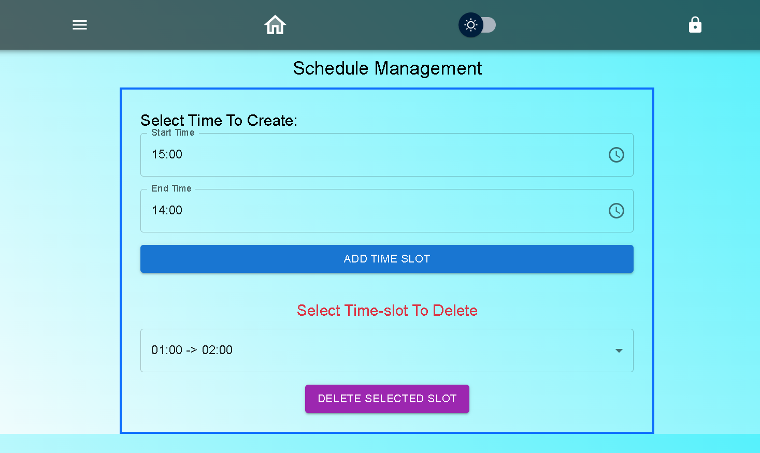

CHAPTER 5
5.1 Data Flow Diagrams:

DFD of Poly-eAttendify:

DFD for PolyQuizzer:

DFD for PolyMicroBuilder:

CHAPTER 6

Result:

// you should attach images of your project UI here.
  - Applications:
- Admissions Portal: Streamline the admission process by allowing prospective students to apply online, submit required documents, and track their application status.
- Course Information: Provide detailed information about courses offered, including syllabi, course schedules, faculty details, and any prerequisites.
- Library Catalog: Allow students and faculty to search for books, journals, and other resources available in the college library, and possibly provide online access to digital resources.
- Events and News: Keep the college community updated about upcoming events, workshops, seminars, and other important announcements through an events calendar and news section.
- Career Services: Provide resources for career guidance, job postings, internship opportunities, resume building, and networking events to help students transition into the workforce.
- Alumni Network: Facilitate connections between current students and alumni through an alumni directory, mentorship programs, and alumni events.
- Feedback and Surveys: Gather feedback from students, faculty, and staff through online surveys and feedback forms to continuously improve the quality of education and campus services.
- Administrative Functions: Support administrative tasks such as managing student records, generating reports, processing payments, and handling inquiries.
- Community Engagement: Engage with the broader community by showcasing the college's achievements, research initiatives, community service projects, and partnerships.

CONTENT 7

7.1 Conclusions:
In conclusion, the development of the VAPM college website represents a significant step towards enhancing communication, accessibility, and efficiency within the educational institution. Through the integration of modern web technologies and user-centered design principles, this project aims to provide students, faculty, and staff with a seamless platform for accessing vital information, resources, and services. By prioritizing user experience and functionality, the website will serve as a central hub for academic updates, event notifications, administrative procedures, and interactive learning materials. Moreover, the implementation of responsive design ensures accessibility across various devices, fostering inclusivity and convenience for all users. As technology continues to evolve, the VAPM college website stands as a testament to the institution's commitment to innovation and excellence in education.

7.2 Future Scope:
The development of the VAPM college website sets the stage for ongoing enhancements aimed at enriching the educational experience and fostering greater engagement among students, faculty, and staff. Moving forward, the project holds potential for integrating advanced features such as virtual classrooms and personalized learning tools to enhance academic delivery. there are several points Which are given below:

- Advanced Features Integration: Continuously incorporating advanced features such as virtual classrooms, interactive study materials, and collaborative tools can enhance the website's utility and engagement for users.

- Community Engagement Platforms: Creating forums, discussion boards, and social networking features within the website can foster greater interaction and collaboration among students, faculty, alumni, and other stakeholders, thereby nurturing a sense of community and belonging.

- Placement Services Portal: Developing a dedicated section for Placement can provide students with resources such as job postings, internship opportunities, resume-building tools, career counseling services, and alumni networking opportunities to support their professional development and transition into the workforce.

- Online Admission Process: Streamlining the admission process through online applications, fee Structure, document and admission inquiery can simplify administrative procedures for both prospective students and college staff, thereby enhancing efficiency and reducing paperwork.

- Virtual Campus Tours: Incorporating virtual reality (VR) or augmented reality (AR) technologies to offer virtual campus tours can enable prospective students and their families to explore campus facilities, classrooms, laboratories providing them with an immersive preview of the college environment.

- Event Management System: Integrating an event management system within the website can facilitate the planning, promotion, registration, and coordination of campus events, including academic conferences, seminars, workshops, cultural festivals, and alumni reunions, fostering community engagement and participation.

- Alumni Engagement Initiatives: Developing initiatives to engage alumni through networking events, mentorship programs, alumni directories, and alumni newsletters can foster lifelong connections and support between past and present members of the college community, promoting a culture of alumni pride and philanthropy.

- Faculty Profiles and Research Showcase: Creating comprehensive faculty profiles that highlight their academic credentials, research interests, publications, and professional achievements can facilitate collaboration and networking among faculty members, as well as showcase the college's expertise and contributions to various fields of study.

- Environmental Sustainability Initiatives: Promoting environmental sustainability through initiatives such as electronic document management, digital textbooks, recycling programs, and energy-efficient practices can demonstrate the college's commitment to environmental stewardship and inspire eco-conscious behaviors among students and staff.

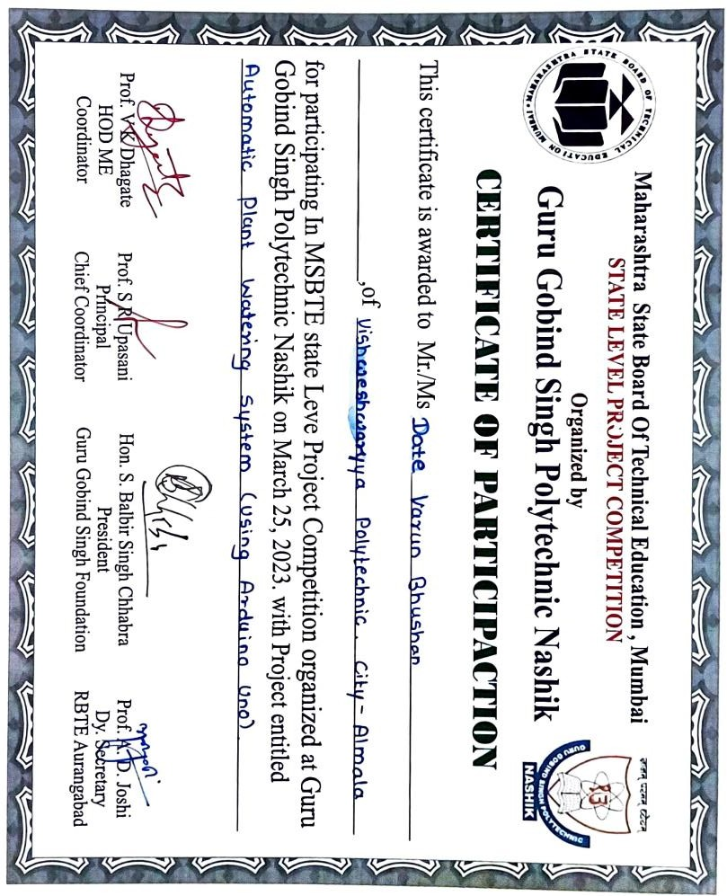

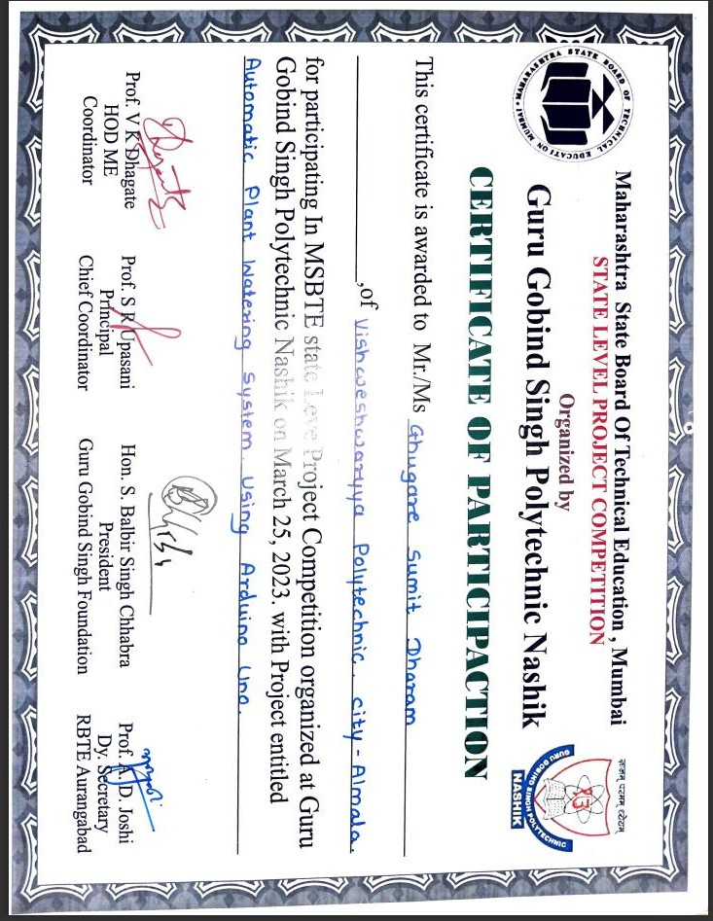

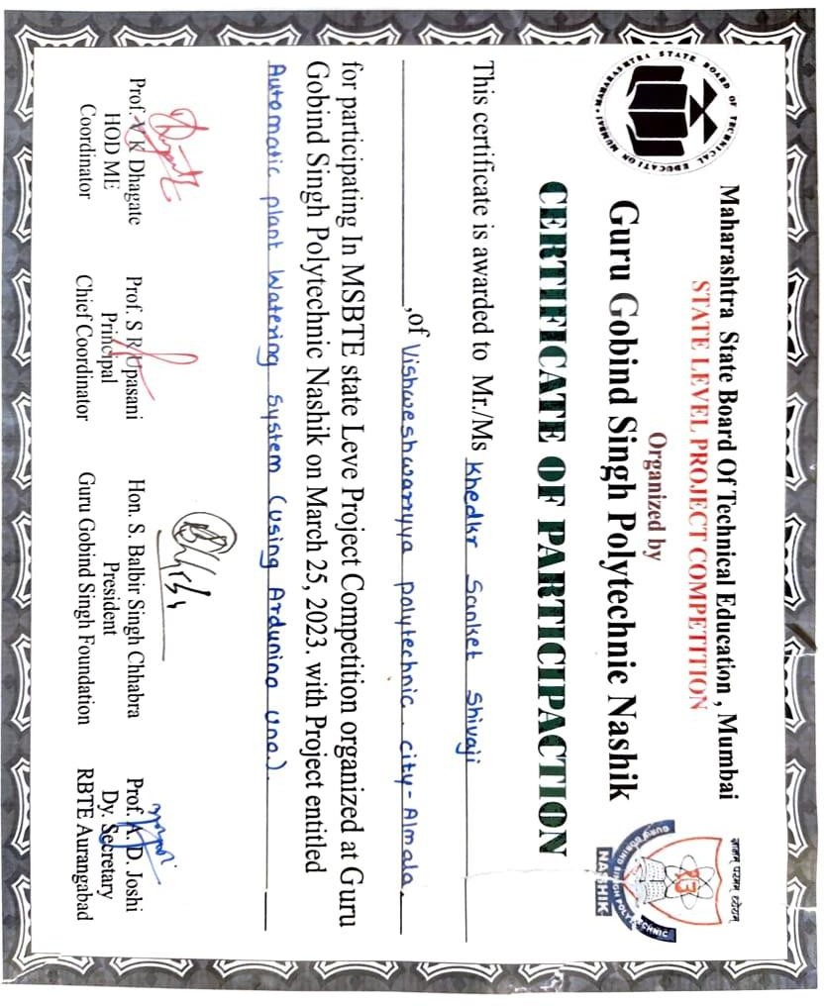





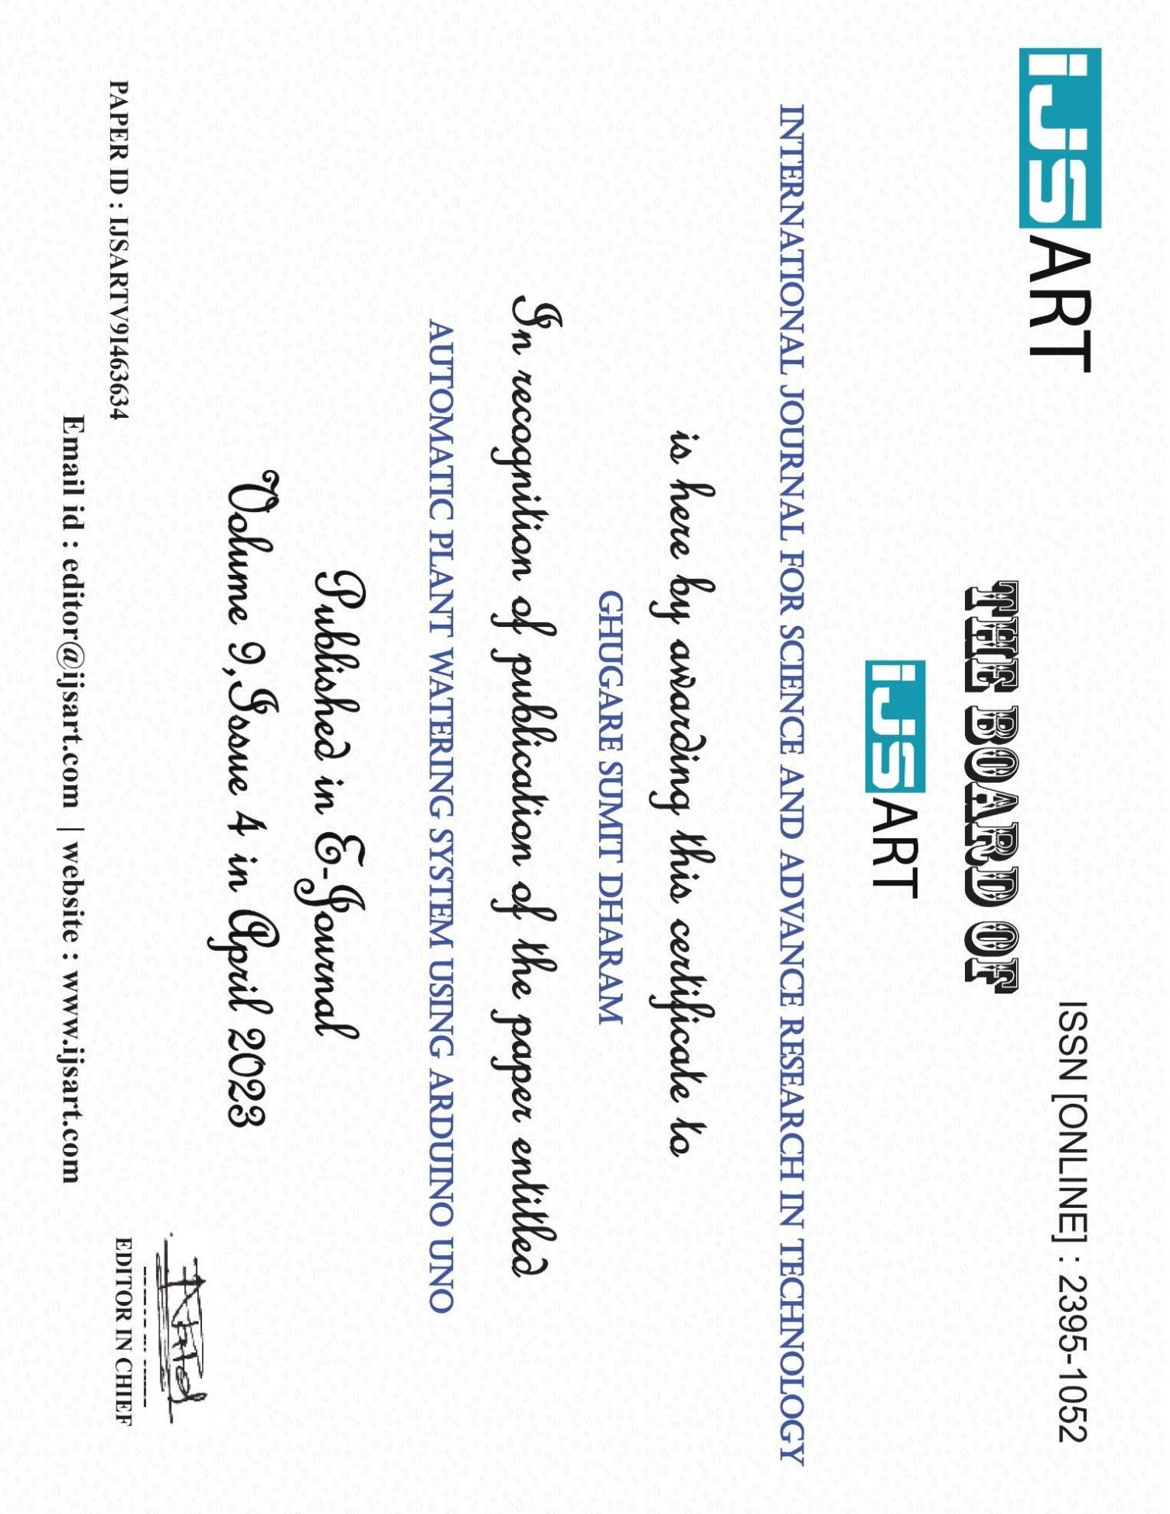

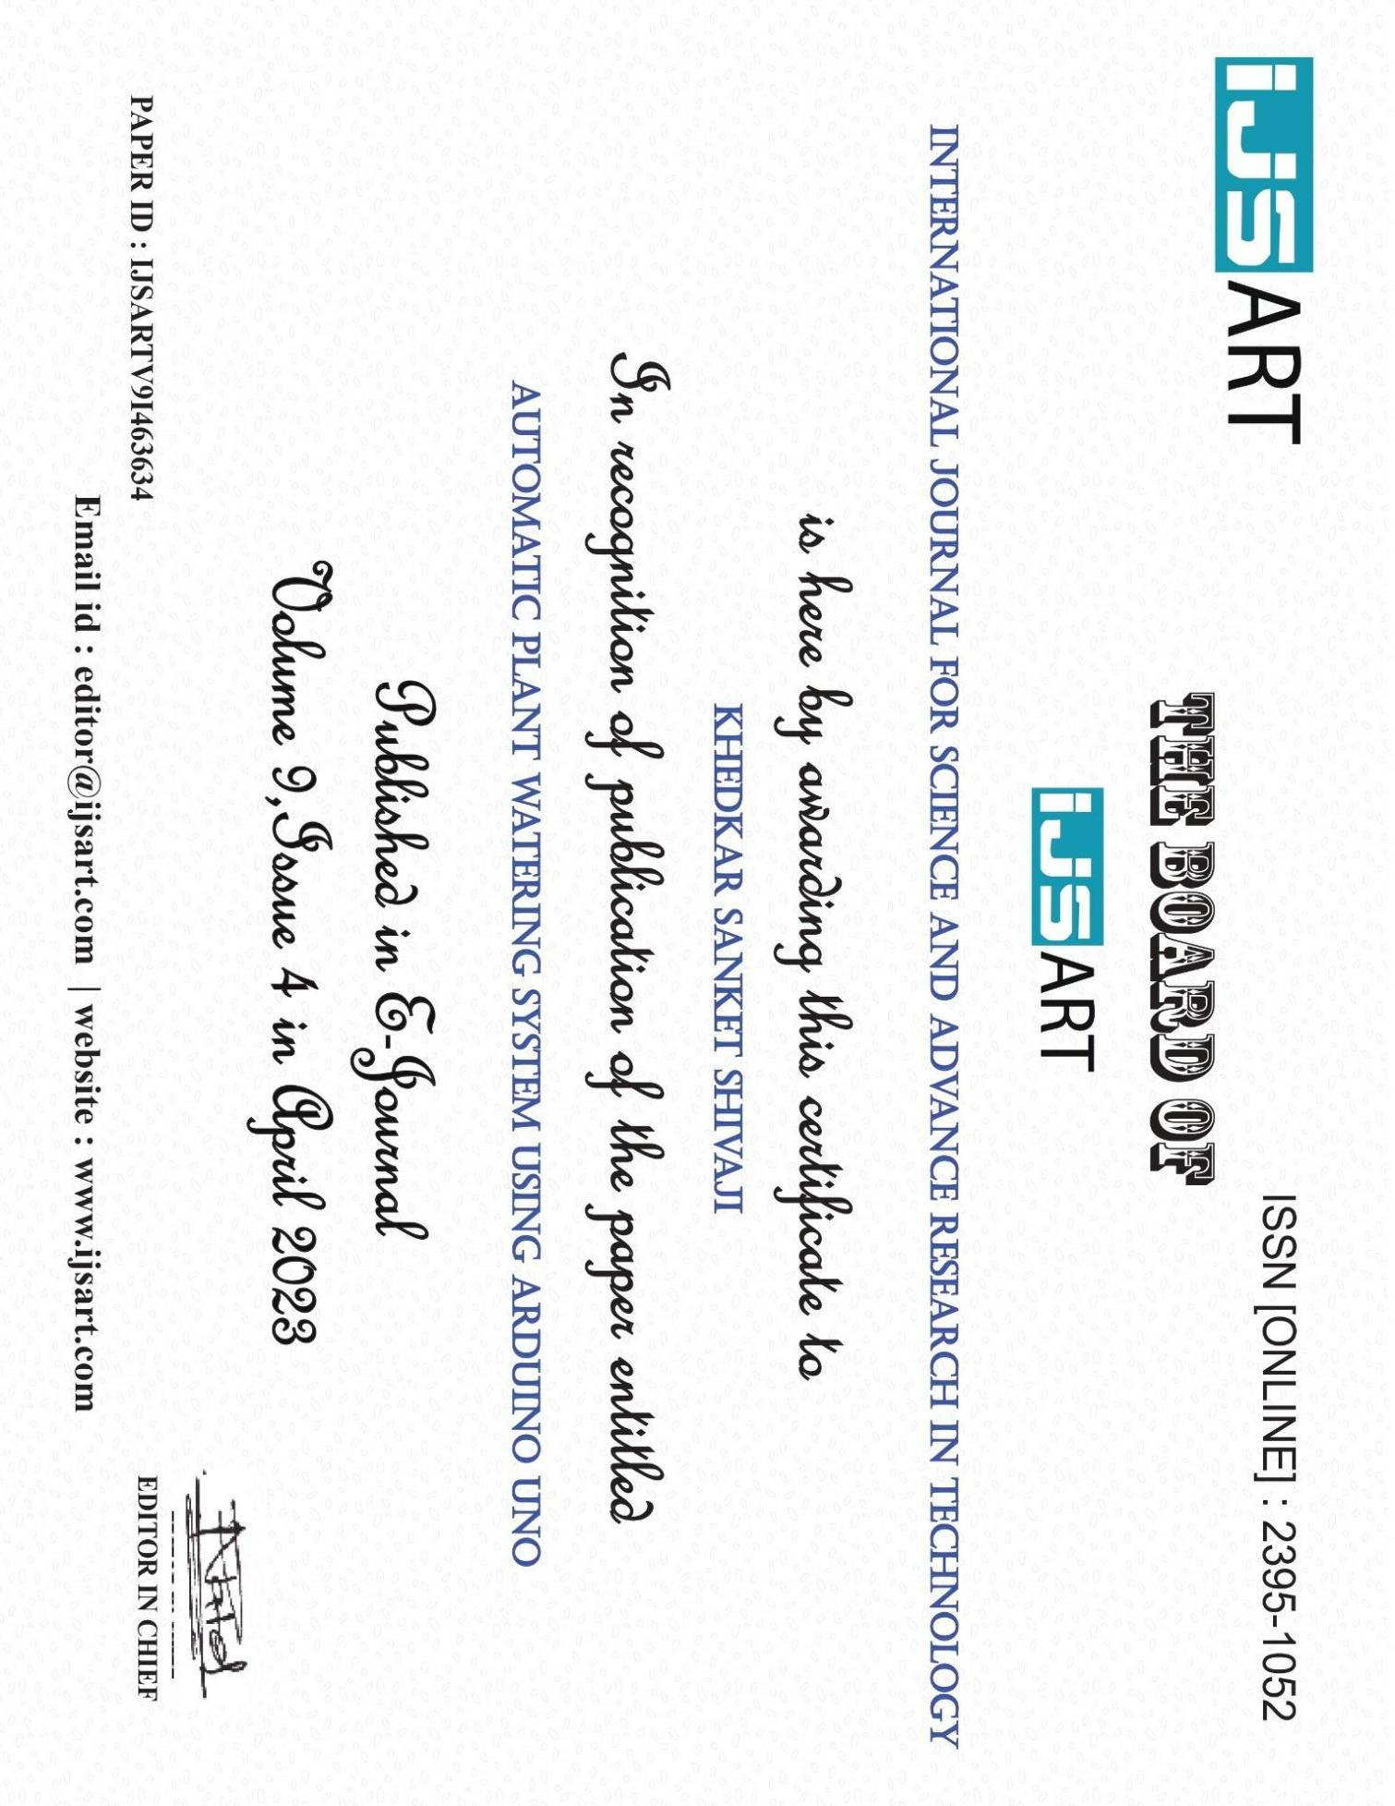

Automatic Plant Watering System Using Arduino Uno
Date Varun Bhushan¹, Gurage Summit Dharam², Khaddar Sanket Shivaji³, Prof. Sugre Dhiraj Dhanraj⁴
^{1,} ^{2,} ³ Dept of Computer Engineering
⁴Guide Lecturer, Dept of Computer Engineering
^{1,} ^{2,} ^{3,} ⁴ Vishweshwarayya Abhiyantriki Padvika Mahavidhyalaya, Almala,Maharashtra,India.

Abstract- Plants require water to grow and thrive, and providing adequate water is essential to ensuring healthy plants. However, manually watering plants can be time- consuming, and it can be challenging to determine the right amount of water needed for each plant. The Arduino-based plant watering system is a project designed to automate the process of watering plants, making it more efficient and effective. The system utilizes an Arduino Uno microcontroller and a soil moisture sensor to sense the moisture level in the soil and water the plants whenever necessary.

  - LITERATURE REVIEW

The Arduino-based plant watering system has gained popularity due to its ease of use, low cost, and efficient water management capabilities. Several researchers have explored the design and implementation of such systems, as well as their potential for future improvements. Overall, the studies suggest that the Arduino-based plant watering system is an effective and efficient solution for automating plant care while reducing water usage. The system's potential for future improvements includes wireless connectivity, data logging, multiple sensors, smart irrigation, and machine learning algorithms.

CONSTRUCTION

The logic of this system is very simple. In this system, the moisture sensor senses the moisture level of the soil and when the sensor senses a low moisture level it automatically switches the water pump with the help of a microcontroller and irrigates the plant. After supplying sufficient water, the soil gets retains the moisture hence automatically stopping the pump

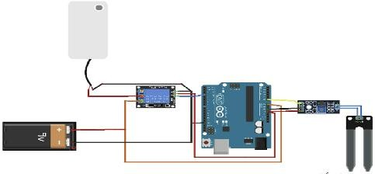
  - Arduino Uno

The Arduino UNO is a standard board of Arduino. Here UNO means 'one' in Italian. It was named as UNO to label the first release of Arduino Software. It was also the first USB board released by Arduino. It is considered as the powerful board used in various projects. Arduino.cc developed the Arduino UNO board.

Arduino UNO is based on an ATmega328P microcontroller. It is easy to use compared to other boards, such as the Arduino Mega board, etc. The board consists of digital and analog Input/Output pins (I/O), shields, and other circuits.

The Arduino UNO includes 6 analog pin inputs, 14 digital pins, a USB connector, a power jack, and an ICSP (In- Circuit Serial Programming) header. It is programmed based on IDE, which stands for Integrated Development Environment. It can run on both online and offline platforms
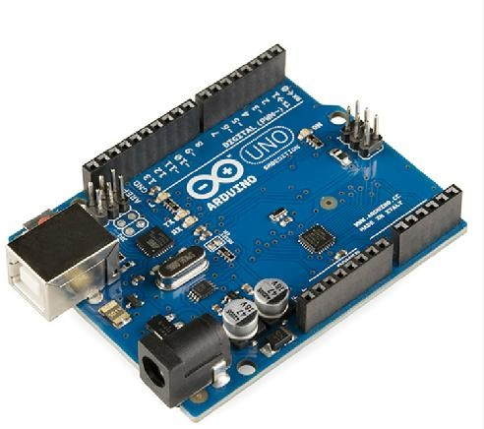
Figure 1.1: Arduino Uno

  - Soil Moisture Sensor

The working of the soil moisture sensor is very easy to understand. It has 2 probes with exposed contacts that act like a variable resistor whose resistance varies according to the water content in the soil. This resistance is inversely

proportional to the soil moisture which means that higher water in the soil means better conductivity and hence a lower resistance. While the lower water in the soil means poor conductivity and will result in higher resistance. The sensor produces an analogue voltage output according to the resistance. The sensor comes with an electronic module that connects the probe to the Arduino. The module has an LM393 High Precision Comparator which converts the analog signal to a Digital Output which is fed to the microcontroller. We have covered an in-depth Arduino soil moisture sensor tutorial which covers the working of soil moisture sensor module and how to use it with the Arduino. You can check the tutorial if you want to learn more about the soil moisture sensor.
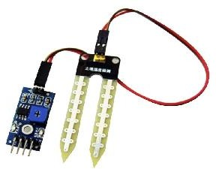
Figure 1.2: Soil Moisture Sensor
A relay is an electronic switch that can be controlled by an Arduino microcontroller to turn a water pump on and off. When the relay is energized, it closes an electrical circuit, allowing electricity to flow through the pump and turn it on. When the relay is de-energized, it opens the circuit, cutting off the electricity and turning the pump off.

To use a relay to control a water pump with an Arduino, you will need to connect the relay to the Arduino ‘s digital output pins. The relay typically has three pins, VCC, GND, and IN. VCC should be connected to 5V of the Arduino, GND to GND, and IN to a digital pin of the Arduino. Once the connections are made, you can use the Arduino ‘s digital Write function to turn the relay on and off, and thus control the water pump.

  - Pump

A water pump that operates at 12V is a type of pump that is designed to run on a 12-volt DC power supply. These types of pumps are commonly used in automotive, marine, and

1.5 Battery 9V

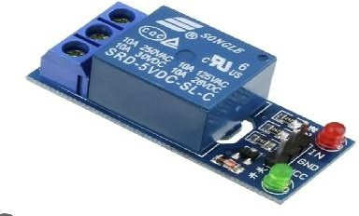
Figure 1.4: Relay

RV applications, as well as in small scale irrigation, water treatment and other similar systems.

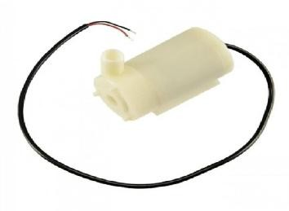
One of the advantages of using a 12V water pump is that it can be powered by a car battery or a deep-cycle battery, which makes it portable and convenient for use in remote locations. Additionally, these pumps are relatively low power and energy efficient, which makes them ideal for use in solar- powered systems.
A 9V battery is a type of primary (non-rechargeable) battery that provides a nominal voltage of 9 volts. It is commonly used in portable devices such as smoke detectors, remote controls, and small electronic toys. 9V batteries are also used in some low-power projects such as small robots and simple electronic circuits.
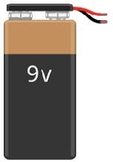
Figure 1.5: Battery 9V

1.4 Relay
Figure 1.3: Pump

  - SOURCE CODE

int moisture_sensor = A0; int moisture;
int limit = 40;
int WATERPUMP = 13;
int sets; void setup()
{
Serial.begin(9600); // opens serial port, sets data rate to 9600 bps;
pinMode(moisture_sensor,INPUT); pinMode(WATERPUMP,OUTPUT);
}
void loop()
{
moisture = analogRead(moisture_sensor); moisture=map(moisture,550,0,0,100); Serial.print("Moisture="); Serial.print(moisture); Serial.println("%");
if (Serial.available());
{
int speed= Serial.parseInt();
{
analogWrite(WATERPUMP,speed)
;
}
if (moisture>limit)
{
digitalWrite(13,LOW);
}
else digitalWrite(13,HIGH);
}
delay(400);
}

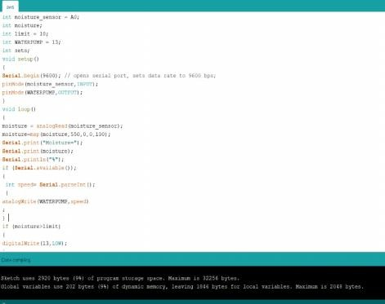

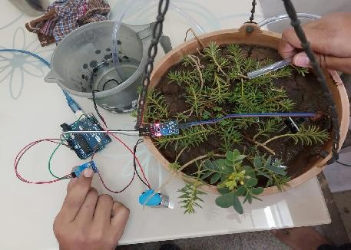

  - RESULT, CONCLUSION AND FUTURE SCOPE 1.Result
- Improved plant growth: With a consistent and appropriate supply of water, plants are more likely to grow faster and healthier.
- Water conservation: An automatic watering system can help to conserve water by only delivering the necessary amount of water to the plants and avoiding wastage.
- Time-saving: The system can save time for the user by eliminating the need for manual watering and monitoring.
- Customization: The system can be customized to meet specific plant watering requirements, such as watering frequency and volume, based on factors like plant species, soil type, and climate.
- Increased efficiency: The system can be designed to operate at specific times of the day or when certain conditions are met, making it more efficient than manual watering.

- Conclusion

the Arduino-based plant watering system is a useful project that can automate the process of watering plants.
The system design involves a moisture sensor, microcontroller, water supply mechanism, power supply, and user interface. The system architecture connects these components together to create a functional system, and the implementation involves programming the microcontroller, designing the user interface, and assembling the water supply mechanism.

This project provides an efficient and effective solution to ensure plants receive water only when they need it, making it an eco-friendly and cost-effective alternative to manual watering.

- Future Scope

- Wireless Connectivity: The system can be enhanced with wireless connectivity such as WiFi or Bluetooth to allow for remote monitoring and control. This would enable users to monitor the moisture level and water their plants from anywhere with internet connection.
- Data Logging: The system can be improved by adding data logging capabilities to track the moisture level over time. This data can be used to analyze plant growth patterns and optimize watering schedules.
- 4Multiple Sensors: The system can be expanded by adding multiple moisture sensors to monitor different plants or sections of a garden. This would enable users to create custom watering schedules for each plant based on its individual needs.
- Smart Irrigation: The system can be integrated with weather forecast data and other environmental factors such as temperature and humidity to create a smart irrigation system. This would enable the system to adjust watering schedules based on the weather forecast and reduce water waste.

REFERENCES

- https://components101.com/ microcontrollers/ arduino-uno
- http://www.circuitbasics.com/setting-up-a-5v-relay on- the-arduino/
- https://vigyanashram.files.wordpress.com/ 2015/05/plant-watering-system.pdf
- https://learn.sparkfun.com/tutorials/installing arduino- ide/all.pdf
- [14 Dez] Devika et al., International Journal of Advanced Research in Computer Science and Software Engineering 4(10), October - 2014, pp. 449-456
- [16 San] Sandeep K. Shukla, IIT Kanpur, Introduction to embedded system, Aug 29, 2016
- [16 SHA] SHAIKH SHEROZ MOHD HASAN, ‘AUTO IRRIGATION USING ARDUINIO’2016
- [17 N.Du] N. Đuzić and D. Đumić: Automatic Plant Watering System and its Applications, Coll.Antropol. 41 (2017)

